2019年九江学院刘坚强赴美国参加Advanced Photonics Congress总结报告

- 出访的基本情况
受美国光学学会2019年先进光子学组委会的邀请，九江学院教师刘坚强于2019年7月29日至8月3日赴美国旧金山参加了先进光子学会议，会议期间作了张贴报告“Enhanced magnetic circular dichroism in graphene oligomers at low static magnetic fields”,与国内外同行进行了充分的学术交流和学习。

- 出访取得的成果
1.充分了解研究前沿
本次会议恰逢美国光学学会成立100周年，会议开设如下主题：集成光子学研究、硅光子学与纳米光子学、新材料与应用、光学器件与太阳能材料及固态光源、光子网络与器件、信号处理与光通讯。大会邀请了包括哥伦比亚大学Keren Bergman、MIT的Bray Robinson、普度大学Alexandra Boltasseva,新加坡量子技术中心Alexander Ling以及中国科技大学Zhang Qiang教授在内的多位知名学者作大会邀请报告。
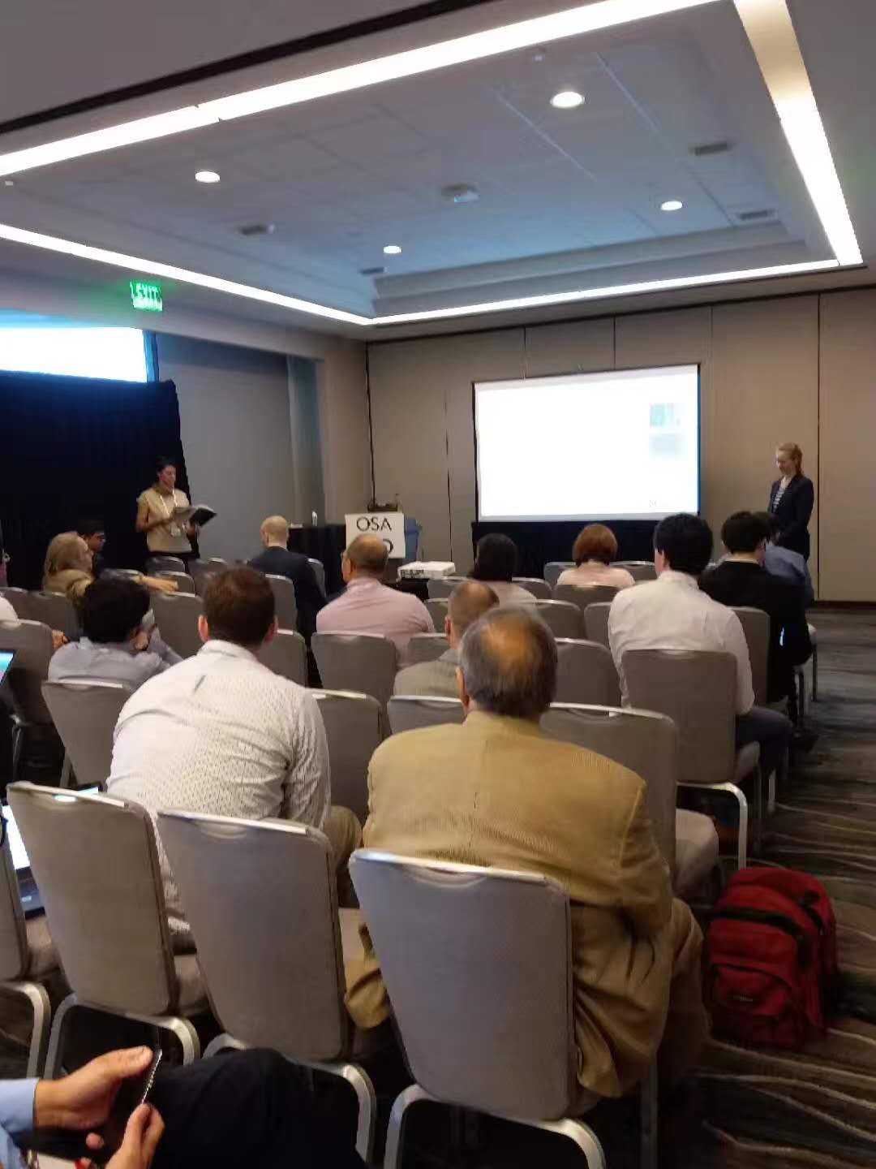
新光学与材料应用分会场报告
氧化石墨烯进展报告

2. 学术交流讨论
会议期间，本人向大会提交了张贴报告“Enhanced magnetic circular dichroism in graphene oligomers at low static magnetic fields”报告如下：

Advanced Photonics Congress (IPR, Networks, NOMA,PVLED, SPPCom) © OSA 2019

Enhanced magnetic circular dichroism in graphene oligomers at low static magnetic fields

Jian Qiang Liu, ^{1,*} Shan Wu, ² Pan Wang, ³ Qing Kai Wang, ¹ Yu Bo Xie, ⁴ Guang Hou Sun, ¹ and Yu Xiu Zhou¹

¹School of Science and the Key Laboratory of Jiangxi Microstructure Functional Materials, Jiujiang University, Jiujiang, Jiangxi Province, China
²Department of Physics, Laboratory of Functional materials and Devices for Informatics, Fuyang
Normal College, Fuyang, Anhui 236032, China
³Department of Physics and London Centre for Nanotechnology, King’s College London, Strand, London WC2R 2LS, UK
⁴ National Laboratory of Solid State Microstructures, Nanjing University, Nanjing 210093, China
Author e-mail address: jqliu2007@163.com

Abstract: Giant magnetic circular dichroism (MCD) is promising for magneto-optical sensing, and nanophotonic devices. We numerically demonstrate that MCD is enhanced three times larger than reported method based on the resonance of electric dipole plasmonic mode.

OCIS codes: 240.6680, 240.5420, 230.3810.

1. Introduction
Most of the reported MCD in metallic or graphene microstructures are based on the bright electric dipole resonance which couples with light directly, needing remarkably large external magnetic field [1-2]. It is due to the low MO activity in nonmagnetic noble metals and large radiation loss of the bright plasmonic resonances. In the present work, we show, under external magnetic field, that the subradiant plasmonic mode has different excitation efficiencies for right-handed circularly polarized (RCP) and left-handed circularly polarized (LCP) incident waves, respectively. Based on this distinctive feature, remarkable MCD effect is revealed with relatively low external static magnetic field. We show that 24% absorption difference is attainable under 0.4 T magnetic field with our designed graphene oligomer-metal substrate array microstructure, which is 3 times larger than MCD based on electric dipole plasmon resonance approach in simple periodic array.

2. Results and discussions

Fig. 1. Schematic of graphene oligomers array and simulated reflection, absorption spectra. (a) Periodic array of symmetric ring of graphene oligomers consisting of 6 graphene disks with radii of 60 nm in each unit cell.

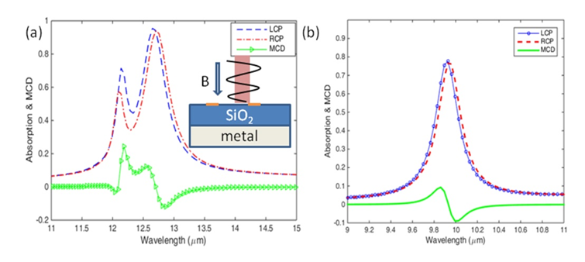
Fig. 2. (a) The absorption (dashed and dot-dashed curves) and MCD (curve with triangular) spectra for LCP and RCP incident wave. The inset illustrates the side view of graphene oligomers array illuminated with circular polarized light under external magnetic field B. The radii of ring oligomers is 160 nm and other parameters are identical to those describe in section 2. (b) The absorption and MCD spectra for a simple periodic array with one graphene disk in each unit cell. The filling factor is identical to the case of panel (a) with oligomer composite structures. Other parameters are the same as panel (a).
In Figure 2(a), around the wavelength of 12.19$μm$ for sharp absorption of LCP, a dramatically increase of MCD is observed, which is two times larger in intensity than the MCD at superradiant mode absorption peak around 12.54$μm$. To compare the increased MCD signal with the reported MCD based on single plasmonic dipole resonant, we also calculated the absorption and MCD spectra for simple periodic array consisting of single graphene disk in each unit cell with identical filling factor, as shown in Fig. 2(b). One can find that the MCD peak is only 8% in Fig. 2(b), which is three times smaller than MCD peak of the subradiant mode displayed in Fig. 2(a).

3. Conclusion

In summary, we have demonstrated an effective mechanism to enhance MCD through the subradiant plasmonic mode in a designed symmetric graphene oligomers. In the mid-infrared region, we show MCD signal is dramatically enhanced to 24% under a relatively low external magnetic field of 0.4 T, which is three times larger than previously reported mechanism based on the resonance of electric dipole plasmonic mode. This giant MCD is attributed to the remarkably different excitation efficiency of subdradiant plasmonic mode due to the collective coupling under circular polarization incidence and external magnetic field.

4. References

[1] M. Wang,Y.Q.Wang, M.B. Pu, C. G. Hu, X. Y. Wu, . Z. Y. Zhao, and X. G. Luo, “Circular dichroism of graphene-based absorber in static magnetic field,” J. Appl. Phys. 115 (15), 154312 (2014).
[2] K. P. Yang, M. Wang, M. B Pu, X. Y. Wu, H. Gao, C. G. Hu and X. G. Luo, “Circular polarization sensitive absorbers based on graphene” Sci. Rep. 6, 23897 (2016).
[3] J. Q. Liu, 1, S. Wu, P. Wang, Q. K. Wang, Y. B. Xie, G. H. Sun, and Y. X. Zhou, “Enhanced magnetic circular dichroism by subradiant plasmonic mode in symmetric graphene oligomers at low static magnetic fields,”, Opt. Express 27, 567 (2019).

三、出访的启示和建议
本次出国参加学术会议，充分了解了国际同行的研究进展，结识了国内外多个高水平课题组的同行，达到了预期的交流效果。主要启示和建议如下：
- 为提高科研水平，高水平的国际学术会议要尽可能多参加。
- 参加会议之前要做好充分准备，对每个会场不同时段的报告主要内容预先了解，有目的性针对性地听学术报告，充分利用会议的间歇时间与本领域专家进行交流、提高口语表达能力。
附：出访人员表
姓名 | 工作单位(部门) | 职务 | 分管工作与出访任务的关联性
刘坚强 | 九江学院科研处 | 副处长 | 学术交流

